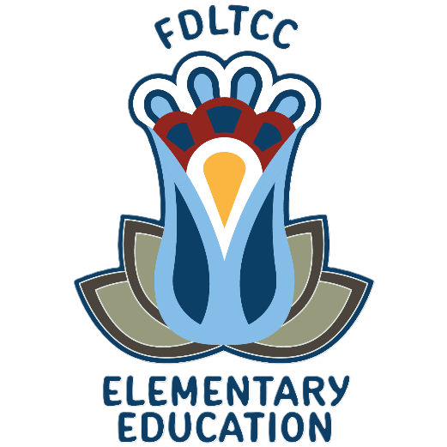

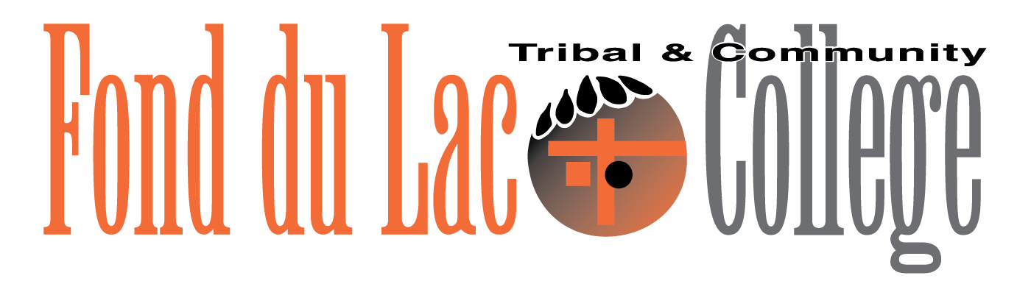

Unit and Conceptual Framework

March 1, 2026
Fond du Lac Tribal and Community College is a member of Minnesota State and the World Indigenous Nations Higher Education Consortium.
An affirmative action, equal opportunity employer and educator.

Contents
Conceptual Framework Introduction 3
Mission and Goals of Fond du Lac Tribal and Community College 3
Vision 4
Values 4
Competencies across the Curriculum (CAC): 4
Cultural Standards Woven Together with Professional Outcomes 4
GIKENDAASOWIN – Knowing Knowledge 5
GWAYAKWAADIZIWIN – Living a Balanced Way 5
ZOONGIDE’EWIN – Strong Hearted 6
AANGWAAMIZIWIN – Diligence and Caution 6
DEBWEWIN – Honesty and Integrity 7
ZAAGI’ IDIWIN – Loving and Caring 7
ZHAWENINDIWIN – Compassion 8

Conceptual Framework Introduction
- The Elementary Education Unit at the Fond du Lac Tribal and Community College (FDLTCC) prepares all teacher candidates within a teacher-preparation pathway that emphasizes cultural approaches to educating future teachers. The unit delivers culturally relevant pedagogy and Indigenous knowledge as well as professional outcomes that aligns to state standards.
- The Institutional Context for the Elementary Education Unit Conceptual Framework FDLTCC is a unique institution, created by the Minnesota Legislature in 1987 and chartered as a tribal college by the Fond du Lac Reservation that same year. The college’s uniqueness comes from the fact that it is a community college that is a member of Minnesota State and a tribal college established through a partnership with the Fond du Lac Band of Lake Superior Chippewa. Because of the Tribal and State partnership, FDLTCC is a higher education institution unlike any other college in the United States that models a central tenet of the Ojibwe Anishinaabe worldview: Interdependent yet autonomous. This pluralistic underpinning can be heard throughout the vision and mission of the college. In 2017, FDLTCC received accreditation by the World Indigenous Nations Higher Education Consortium (WINHEC). Recognized as an international accrediting authority, WINHEC strengthens and validates indigenous higher education institutions and programs by promoting and acknowledging indigenous epistemology and pedagogy. WINHEC provides an international forum and support for indigenous peoples to pursue common goals through higher education. WINHEC is founded according to the United Nations Declaration of the Rights of Indigenous Peoples. The WINHEC accreditation specifically applies to Anishinaabeg Gikendaasowinan (the People’s way of knowing) American Indian Programs at FDLTCC. Anishinaabeg Gikendaasowinan’s mission is to promote, honor and value the language, history, worldview, and knowledge of the Ojibwe-Anishinaabe people, thereby ensuring the longevity of the Ojibwe-Anishinaabeg culture.

Mission and Goals of Fond du Lac Tribal and Community College
The mission of FDLTCC is to provide higher education opportunities for its communities in a welcoming and culturally diverse environment. To achieve this mission FDLTCC will:
- Promote scholarship and academic excellence through transfer and career education, and to provide access to higher education by offering developmental education.
- Respectfully promote the language, culture and history of the Anishinaabeg.
- Provide programs which will celebrate the cultural diversity of our community and promote global understanding.
- Promote a sense of personal respect and wellness.
- Provide technological opportunities and experience, preparing students for the future.
- Provide programs and baccalaureate degrees that fulfill our commitment to American Indian communities, our land grant status, and the union of cultures.

Vision
Fond du Lac Tribal and Community College offers a postsecondary education to honor the past, for those living in the present and dreaming of the future, through a spirit of respect, cooperation, and unity.

Values
Fond du Lac Tribal and Community College has established five College Values which include the following:
- Respect (Manaaji’idiwin)
- Integrity (Gwayakwaadiziwin)
- Stewardship (Ganawenjigewin)
- Innovation (Maamamiikaajinendamowin)
- Compassion (Zhawenjigewin)

Competencies across the Curriculum (CAC):
Learning outcomes are based on a common foundation of Competencies across the Curriculum (CAC) that is consistent throughout the curriculum in all delivery modes; they are explicitly evident on each course outline and form the foundation of the college’s assessment process.
- Problem-solving: The student will be able to conceptualize, apply, analyze, synthesize, and/or evaluate information to formulate and solve problems.
- Ability to communicate: The student will be able to demonstrate the ability to listen, read, comprehend, and deliver information in a variety of formats.
- Information literacy: The student will be able to demonstrate the ability to use print and nonprint tools effectively for the discovery, acquisition, and evaluation of information
- Culture: The student will be able to demonstrate knowledge of Anishinaabe traditions and culture, knowledge of his/her own traditions and culture, knowledge of other’s 3 traditions and cultures, and respect for global diversity

Cultural Standards Woven Together with Professional Outcomes
The unit has adopted the cultural standards of the WINHEC accredited American Indian Programs and adapted them to meet the specific needs of the education unit. Professional outcomes were developed from the cultural standards. Both the cultural standards and the professional outcomes flow from the unit’s vision and mission to provide a unique perspective on teaching and learning.

The cultural standards and professional outcomes direct the unit’s thinking, planning, actions, and initiatives (see figure 1).

GIKENDAASOWIN – Knowing Knowledge
To prepare our teacher candidates to be problem solvers who strive for continuous learning and growth.

Disposition: Integrates Content and Pedagogical Knowledge. Teacher candidates demonstrate their ability to integrate content and pedagogical knowledge by weaving the following into their teaching:
- Technology: Use technology effectively to improve student learning.
- Theory to Practice: Applies current theory, research, and best practices to improve one’s professional practice as a teacher.
- Critical and Connected Thinking: Engages in critical thinking that reflects analysis, problem solving, and incorporates world views and community knowledge to create culturally relevant instruction.
- Reflective Practice: Demonstrates self-reflection and incorporates professional feedback to adjust for continuous improvement in professional practices and effective instruction.

Professional Outcome: Content and Pedagogical Knowledge
- To develop teachers who value and utilize knowledge, learning, and critical thinking that is central to Indigenous and other ways of knowing.

GWAYAKWAADIZIWIN – Living a Balanced Way
To provide teacher candidates the opportunity to recognize the importance of living in harmony with the community and are prepared to use a collective approach to understanding and deciding on a course of action.

Disposition: Communication and Collaboration. Teacher candidates demonstrate professional, interpersonal, and communication skills. These skills are used to promote positive collaborative partnerships with students, families, colleagues, other school professionals, and the global community to support achievement of student learning outcomes.

Reflective Collaboration: Uses insights and inspiration of others to improve practice and can occur in:
- Professional Learning Communities
- Mentoring Programs
- Peer Observations
- Critical Friends Groups
- Community Involvement: Demonstrates positive collaborative skills in interactions with instructors, advisors, students, colleagues, parents/ guardians/caregivers, school teams, and those in the wider community.
- Communication: Effectively and accurately communicates ideas, thoughts or visions (oral and written) and engages in active listening based on audience and community cultural norms.

Professional Outcome: Community and Collaboration
To develop teachers who are reflective, connected educators who understand the interrelatedness of educating the whole child by including the community.

ZOONGIDE’EWIN – Strong Hearted
To provide a foundation on which we build and strengthen each teacher candidate’s resilience, innovation, and passion.

Disposition: Vision and Leadership Teacher candidates demonstrate the vision and skills necessary to lead and manage classrooms and schools as complex, adaptive systems in a changing world.
- Demonstrates skills and qualities that lead to meaningful change.
- Models and fosters respect for all cultures, identities, and perspectives in words and actions and consider historical pasts to prepare for the future.
- Listens and responds to community needs and understands cultural norms as opportunities for growth and development.

Professional Outcome: Transformational Leadership
- To increase the teachers’ leadership capacity to live and walk with a strong heart, respectful and open to new ideas and courageous enough to confront the accepted truths of history and society.

AANGWAAMIZIWIN – Diligence and Caution
To develop teacher candidates’ capacity to proceed carefully, after identifying, discussing and reflecting on logical and ethical dimensions of political, cultural, social, and personal life.

Disposition: Ethical Behavior. Teacher candidates demonstrate professional integrity through behaviors and actions that reflect state and FDLTCC ethical and cultural standards.

- Demonstrate professional and ethical conduct with faculty, faculty supervisors, cooperating teachers, students, parents, colleagues, and community.
- Practices, complies, and understands the school site and the college and unit policies (e.g., academic honesty), as well as Minnesota Code of Ethics for Teachers.
- Adheres to all professional standards, including the use of technologies (e.g., accesses authorized websites, social media and other applications, and uses personal electronic devises as appropriate).

Professional Outcome: Ethical Practitioner
- To develop teachers’ capacity to be ethically responsive in respecting their role as an educator and understanding community needs.

DEBWEWIN – Honesty and Integrity
Encourage teacher candidates to develop a deeper appreciation of their own worldview and the worldview of others.

Disposition: Data-Informed Practice. Teacher candidates demonstrate ability to make data-driven decisions as they plan, implement, and evaluate instruction.
- Uses student data to plan and implement instructional strategies and activities.
- Uses assessment data to identify student strengths and deficiencies and adjusts practice based on results.
- Uses formal and informal assessment strategies to evaluate and ensure the continuous intellectual and social development of the student.

Professional Outcome: Assessment and Use of Data
- To expand teachers’ potential to think and act with honesty and integrity as they use multiple types of assessment strategies to evaluate student progress and guide student learning and development.

ZAAGI’ IDIWIN – Loving and Caring
To encourage the teacher candidates’ development of healthy, caring relationships built on respect for all.

Disposition: Equity, Social Justice, and Inclusion. Teacher candidates demonstrate fairness, empathy, and compassion based on their belief that everyone can learn. Candidates actively seek out multiple perspectives and diverse experiences to address the academic, interpersonal, and emotional needs of all students.
- Demonstrates and appreciation of the languages, communities, and experiences students bring to the classroom.
- Advocates for and supports Indigenous and other diverse communities and individuals.
- Respects the dignity and essential worth of all individuals.
- Interacts with sensitivity to community and cultural norms.
- Values and responds to all aspects of a child’s developmental well-being (cognitive, emotional, psychological, social, and physical).
- Promotes the diversity of opinions, ideas, and backgrounds.

Professional Outcome: Diversity
- Promote teachers’ acceptance and respect of the diversity within their school, community and environment

ZHAWENINDIWIN – Compassion
To encourage teacher candidates to develop an empathetic appreciation of the arts and humanities as a way to understand the human experience.

Disposition: Life-long Learner. Teacher candidates engage in professional growth and encourage curiosity and inquiry as reflective agents of change by sharing knowledge responsibly and participating as a community resource.
- Demonstrates commitment to professional development and intellectual curiosity.
- Practices current skills while demonstrating ability to adapt and develop new skills.
- Actively participates or fosters the positive professional learning environment within the school community as well as the school- home relationships.
- Analyzes various professional contexts, resulting in more informed decision-making about professional practice.

Professional Outcome: Generation of New Knowledge
- To expand teachers’ knowledge of the human condition and cultures, and the importance of compassion especially in relation to behavior, ideas, and values.

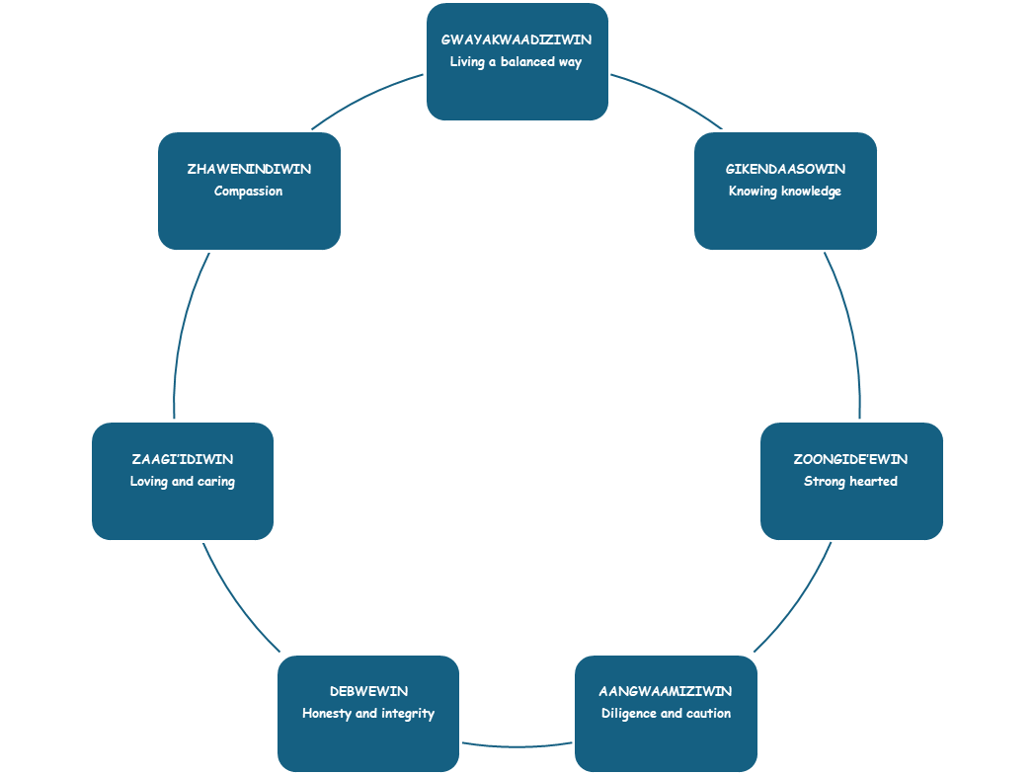

The seven cultural standards and professional outcomes shape and map out the unit’s elementary education curriculum. Faculty take that curriculum and use a culturally responsive approach to pedagogy to reinforce the values of Anishinaabe culture, traditions, and ways of knowing throughout the content and includes professional dispositions required of the unit’s teacher candidates. The cultural standards also reflect the ways that the unit’s faculty incorporate local ways of knowing and teaching into their practice. This can be seen with the use of the local environment and community resources to link what they are teaching to the everyday lives of the candidates, as well as using indigenous knowledge as part of the foundation for the curriculum.

Culturally responsive pedagogy (CRP) “recognizes students’ differences, validates students’ cultures, and asserts that cultural congruence of classroom practices increase student success in schools” (Ragoonaden, 2017, p. 24). It is an approach that that focuses classroom curricula and practice on students’ cultural frames of reference (Gay 2010; 2013). While Indigenous teachings is focused specifically on Indigenous knowledge, it also compliments and reinforces CRP.
Indigenous knowledge provides that every student whether Aboriginal or not, is unique in his or her learning capacities, learning styles, and knowledge bases. Knowledge is not what some possess and others do not; it is a resourceful capacity of being that creates the context and texture of life. Thus, knowledge is not a commodity that can be possessed or controlled by educational institutions, but is a living process to be absorbed and understood (Battiste 2002, p. 15).

According to Barnhardt and Kawagley (2008) Indigenous knowledge comprises the “information that people in a given community, based on experience and adaptation to a local culture and environment, have developed over time, and continue to develop. This knowledge is used to sustain the community and its culture and to maintain the genetic resources necessary for the continued survival of the community” (pp. 235-236).

In addition, Arsenault et al., 2018: Diver et al., 2019 Kovach, 2009; McGregor, 2014; Tobias, 2009; Wilson, 2008 emphasize the two-eyed seeing approach to employ more holistic research approaches used in Indigenous methodologies. And encourages reciprocal learning through knowledge exchange-between Indigenous community members and academic researchers as well as within Indigenous communities.

The FDLTCC Education Unit is unique in that it focuses on Indigenous knowledge from the Anishinaabe perspective and incorporates CRP, while at the same time effectively weaving state standards into the curriculum in order to strike a balance between formal and non-formal, and between traditional and modern teaching methods. It is also important to note that while the unit is focused on Indigenous knowledge and CRP, it is also grounded in professional theory and current research applied to the educational settings (e.g. Dewey, Vygotsky, Piaget, Gardner, Darling-Hammond, and Freire). The unit faculty provides teacher candidates with the academic and pedagogical context to integrate research and standards-based curricula into practice and provides knowledge on how Anishinaabe cultural, linguistic, ethnic and experiential backgrounds contribute to solving problems. Key assessments linked to state standards ensure that teacher candidates demonstrate the ability to work with students, families and community in ways that reflect the various proficiencies ethical behaviors, and dispositions expected of them as professional educators, as well as the understanding and values that are consistent with the belief that all students can learn.

Importance of Indigenous Knowledge in Teacher Education Programs
Few pre-service teacher education programs have “developed any insight into the diversity of the legal, political, and cultural foundations” of Indigenous peoples. In addition, most teacher education programs incorporate Indigenous knowledge as a component of multicultural education, if it is addressed at all. Therefore, when teachers encounter cultural difference, they have very little theory, scholarship, research, or practice to draw upon when working with Indigenous students, their parents, and the community (Battiste, 2005, p. 5).

It has long been assumed that Native teachers can provide the necessary Indigenous resources and knowledge. However, it is important to note that most Native educators have been trained in the same teacher training program as all other teachers and come with their own diverse histories and experiences related to Indigenous knowledge. Battiste and McLean (2005) noted that:
They [Native educators] receive the same Eurocentric mainstreamed education as other teachers, but are expected to be the solution to the systemic issues affecting students’ disaffection with education. Some teachers may speak the students’ native language, but they receive little or no language methodologies and cultural pedagogies in conventional teacher preparation. Few universities offer the theories or methodologies, or protocols on learning diverse skills capable of withstanding multiple forces of racism with caring, love, and respect (p. 8).

The unit recognizes that Native teacher candidates may differ significantly in terms of understanding their history, language and cultural practices. The unit’s conceptual framework takes into consideration these differences and scaffolds Indigenous teachings and knowledge into the curriculum and uses CRP to support their teacher candidates as they attain knowledge and skills needed to be effective educators.

Culturally Responsive Pedagogy
Multicultural education that focused on recognition and inclusion has shifted to a more intentional paradigm of culturally responsive pedagogy. CRP “relies on educators connecting to their students’ backgrounds, building on students’ home dialects and languages, planning for dialogic instruction, attending to classroom discourse, and maintaining a rigorous curriculum”

(Richardson & Dinkins, 2014, p. 59). CRP requires that educators understand the cultural practices and backgrounds of diverse students CRP “recognizes students’ differences, validates students’ cultures, and asserts that cultural congruence of classroom practices increase students’ success in schools” (Ragoonaden, 2017, p. 47).

Grant and Gibson (2011) found that that the best predictors of success in education are life experiences, attitudes, disposition toward difference, and a commitment at individual and institutional levels to embody an inclusive pedagogical practice such as CRP. CRP is not a type of pedagogy that could be turned on and off but rather requires a continued exchange of ideas and requires careful classroom planning. In pre-service teacher education programs, mentorship within teacher education program as well as teacher candidate collaboration is key to successfully implementing CRP.

With continued efforts Smith, Diver, and Reed (SAGE 2023) emphasize to use personal experiences to normalize the two-eyed seeing from a variety of perspectives, we are working from our own experiences, we are also coming to our analysis through the lens of basketweaving and ceremonial trails. We also draw on years of experience working through an allied approach to ecocultural revitalization in these domains, which include using science and engaging in dominant systems.

References
Arsenault et al., 2018: Diver et al., 2019 Kovach, 2009; McGregor, 2014; Tobias, 2009; Wilson, 2008, (2023) Advancing Indigenous futures with two-eyed seeing: Strategies for restoration and repair through collaborative research. SAGE Journal, 2 (1-2).
Barnhardt, R., & Kawagley, A., (2008) Indigenous knowledge systems and education. In Yearbook of the national society for the study of education, chapter 16, 107(1), 1-314. Retrieved from https://doi.org/10.1111/j.1744-7984.2008.00144.x
Battiste, M. (2002). Indigenous knowledge and pedagogy in First Nations education: A literature review with recommendations. National Working Group on Education and the Minister of Indian Affairs. Ottawa, ON: Indian and Northern Affairs Canada.
Battiste, M. (2005). Indigenous knowledge: Foundations for First Nations. Worm Indigenous Nations Higher Education Consortium Journal, 1-17.
Gay, G. (2010). Acting on beliefs in teacher education for cultural diversity. Journal of Teacher Education, 61(1–2), 143–152.
Gay, G. (2013). Teaching to and through cultural diversity. Curriculum Inquiry, 43(1), 48–70. doi: 10.1111/curi.12002
Grant, C., & Gibson, M. (2011). Diversity and teacher education: A historical perspective. In Ball, A., & Tyson, C. (2011) (Eds), Studying Diversity in Teacher Education: Lanham, MD: Rowman & Littlefield.
Ragoonaden, K. (2017). Culturally responsive pedagogy: Indigenizing curriculum. Canadian Journal of Higher Education, 47(2), 2017, 22 –46.
Richardson, B. C., & Dinkins, E. G. (2014). Life on the Reservation: Cross-Cultural Field Experiences and Student Learning. AILACTE Journal, 11(1), 57–72.
Smith, C., Diver, S., Reed R., (2023) Advancing Indigenous futures with two-eyed seeing: Strategies for restoration and repair through collaborative research. SAGE Journal, 2 (1-2)

