Classroom Management Plan

Nahin Gatica Cruz
Fond du Lac Tribal and Community College
ANSH 2010 Anishinaabe Language for the Classroom
Professor Michelle Goose/Zhooniyaa-ikwe
April 26, 2023

Elements For a Great Classroom Management
Introduction:
Classroom management is as important for teachers as it is for students. It gives teachers the potential to teach and successfully deliver their daily instructions. As for the students, the potential to learn and academically succeed. Classroom management is particularly important when teaching since it helps to improve the environment in the classroom and school, giving the students and teachers a smooth experience during their learning and teaching period.
Classroom:
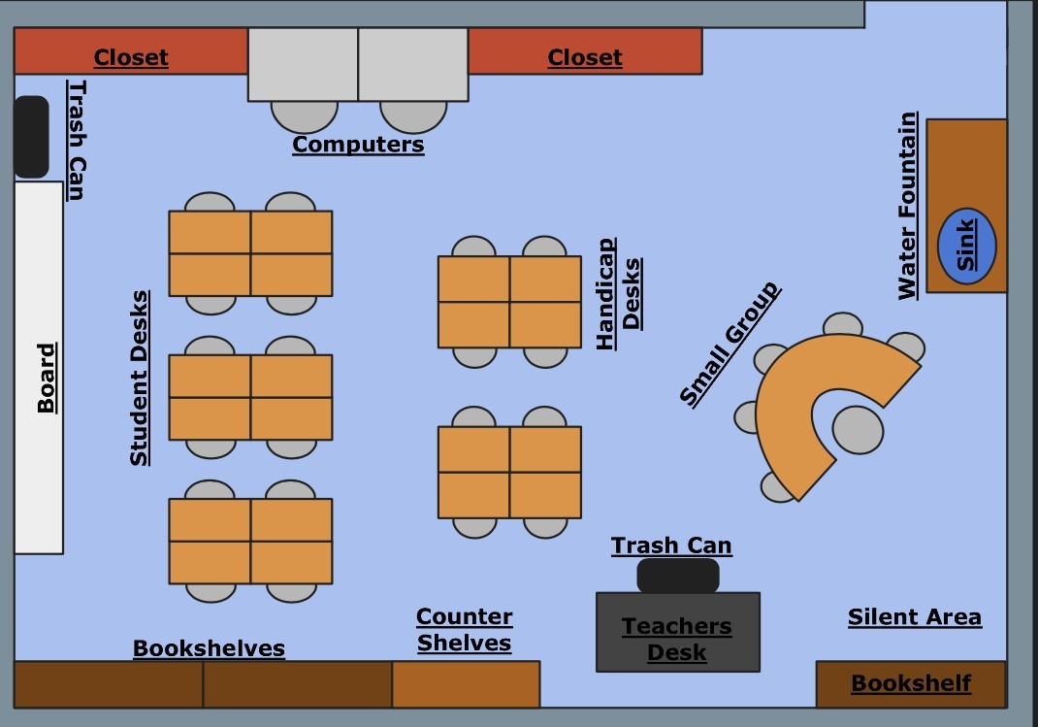
In order to have a safe environment in the classroom teachers must consider managing a safe classroom by having it clean, arranging low-traffic areas, giving the students personal and quiet space, and avoiding blind spots. My first classroom setup covers the qualities mentioned. It is very important to also have a place where the teachers and students can meet in a circle. I think that is what I would add to my classroom setup, a place in front of the classroom where students and I would meet in a circle. During my practicum time in the classroom, I noticed how important it is to have a place where the students can meet each morning for morning meetings in a circle. “We feel connected to other people when we sense that they see us, know us, and care about us. That’s what connection circles are about: being seen, being heard, being known, and developing affection.” (Community Building with Circles, 2023). Knowing our students, but also getting our students to know each other is a crucial component to having a culturally responsive classroom. To aid students to follow procedures and expectations teachers can incorporate in the classroom different resources to help them visualize the expectations and procedures such as posters in different languages. Through this essay, I will be adding some procedures in Ojibwe that can be added to different scenarios for better classroom management.
Morning Meetings:
Morning meetings are an essential part of culturally responsive classroom management that can help to build a strong relationship within the whole group. “Morning Meeting is an engaging way to start each day, build a strong sense of community, and set children up for success socially and academically.” (Responsive Classroom, 2022). When implementing morning meetings as a routine in the classroom, the students get to know each other better, helping them to foster a safe and positive environment in the classroom. During morning meetings, the students can share, check in, greet, participate in a group activity, and give a morning message. Morning meetings are especially important for teachers because they can help them identify students’ cultural backgrounds. Morning meetings help students to get to know each other better, fostering a connection between students to work in groups during the day.
Some expectation in Ojibwe used for morning meetings are:
- Sit in a circle! - Waawiiyebig!
- Be calm and quiet! - Bizaani-ayaan!
- Raise your hand! - Ombinikenin!
- Let’s listen to him or her - Bizindawaadaa.

Brain Breaks
Brain break activities are very important on a daily basis for students since they help the students to reduce their stress, anxiety, and frustration. There is a significant list of brain breaks that teachers can incorporate into their classrooms. The use of posters in the Ojibwe language, such as those from Dr. Dan, should be great for some brain break activities. These are some examples of brain break activities that teachers can incorporate into the classroom.:
Stretch it out! It is an active physical brain-break activity that can be done right next to the student's table or in front of the classroom when transitioning. This is an activity that can be for kindergarten to twelve graders, and it can be done by all students. This activity can be performed by having the student stand up to make them reach above their heads, and then making them bend down to reach their toes with their fingers. They can also move their hips in a clockwise and counterclockwise rotation. Or it can be performed by making the student sit down, and make them stretch their hamstrings, glutes, quads, and calves. This brain-break activity might be good for transitioning after the students have been sitting for a long time.
Yoga is a great brain-break activity that helps students reduce anxiety, and it can also help them improve their emotional regulation, strength, and flexibility. Yoga is an activity that can work well from kindergarten to higher grade levels. To make yoga a more successful activity, teachers can add different possess such as downward dog, tree pose, start pose, and more.
Social Emotional Learning is another fundamental key for a culturally responsive classroom since students learn to think about ways the environment can be used to communicate respect for diversity. Roger Weissberg claims in his article that “Educators and community agencies serve students with different motivations for engaging in learning, behaving positively, and performing academically. Social and emotional learning (SEL) provides a foundation for safe and positive learning, and enhances students' ability to succeed in school, careers, and life.” (Weissberg, 2016). Teachers can incorporate SEL activities into morning meetings or throughout the day, into brain breaks. SEL activities help students to practice social-emotional learning skills which are fundamental to help them with their behavior in the classroom since the skills learned in the activities improve their relationships with themselves and others by developing skills like empathy, conflict resolution, and the ability to manage emotions.
Teachers need to make sure to have enough room in the classroom to implement diverse types of brain breaks. Since some brain breaks require locomotor skills, we need to make sure to have a safe area in the classroom to perform them. It is also important to make sure that students know the expectations that are require during brain, some of them can be:
- Behave good! - Mino-izhiwebizin!
- Don’t bother anyone! - Gego babaamenimaaken awiiya!
- Let's Help each other! - WiidookodaadiDaa!
- Be good to each other! - Minodoodaadig!
Transitions: Expectation, Re-teaching
Teachers need to be repetitive, meaning that they need to re-teach procedures if needed. I have witnessed that one time is not enough for students to learn the procedures that take place in the classroom. Some students need more time to learn the procedures as well as the expectations. I noticed that my coach teacher uses a smartboard to place the procedures of her classroom in between transitions. During transitions, my coach teacher always has on her smart board display the procedures to follow for the next subject/class. She also lists the material that students will need, the agenda, the learning targets, and a timer with a countdown timer. Usually, the countdown that is displayed is for three minutes, during those three minutes, the students need to go to the restroom if they need to, and they need to gather what is needed for the next subject/class. If some students need to go to the restroom during class time, she also uses non-verbal communication.
“Non-verbal communication” is a great strategy to use to not cause disruption during the class as well as to express approval or admiration of behavior, participation, permissions, etc. One example would be teaching the students to raise their hands showing two fingers (middle and pointer) to ask permission to go to the restroom, then the teacher would nod his/her head to give permission. This will prevent disruptions in situations such as when reading.
The use of visual aid for students to see the expectations and procedures are especially important since it might be helpful for students that need a visual aid to help students with their understanding but also to help them remember the expectations and procedures. Winifred Montgomery emphasizes in her article Creating Culturally Responsive, Inclusive Classroom that “An important component of an effective culturally responsive classroom is the use of a range of instructional methods and materials.” (Montgomery, 2021, p.2). Having diverse materials to help students remember expectations and procedures such as displaying them on the board helps have a smooth transition in the classroom. When I was observing the class, I noticed that all students are used to this approach. I am willing to use this strategy in my own classroom, but I am planning to also incorporate as many posters with expectations and procedures as possible to help students understand and visualize them and to help me as an aid for re-teaching the procedures, and expectations.

Belonging:
Teachers also need to commit to building caring classroom communities. The students in the classroom need to feel “belong.” “Belong” can be classified as caring and loving no matter your race, gender, location, family, culture, disabilities, etc. Belonging is a place where you build a community with a strong social connection, and you feel safe. It is when people build bonds in a place to feel safe, a place where you talk and you are heard, a place where people know who you are, and you know who they are, a place where they care for you and love you.
The environment in my classroom for a student needs to be like being at home. The classroom needs to be a place where students feel safe (supported, engaged, and accepted), but of course, the teachers need to commit to creating that environment in the classroom. If a student feels safe in a classroom, then that student would also feel accepted, if the student feels accepted then he/she would feel supported and, having those pillars he/she would engage. We as teachers need to make sure to listen to the students, call them by their names, teach them how to work as a team/family, teach them to care for each other, and teach them to love each other. The classroom needs to be like a small community welcoming all cultures and where core values need to be integrated. Teachers need to create a place where everyone works together to follow the core values to live in harmony. Values such as:
- Respect: Manaaji’idiwin
- Integrity: Gwayakwaadiziwin
- Stewardship: Ganawenjigewin
- Innovation: Maamamiikaajinendamowin
- Compassion: Zhawenjigewin
Having a safe physical and mental environment in the classroom is particularly important to foster a good relationship between all individuals in the school. Teachers also need to be role models and teach students to respect themselves, and others. Teachers should also know their students, smile at them, including their culture, and foster the prevention and resolution of conflicts. We need to create the classroom as a place where students belong, a place where they feel safe, and a place where they feel at home.
A teacher must create a safe (physical and mental) environment in the classroom, if this is accomplished, then the students would have higher academic achievement, and improve their attendance and their behaviors. “Teachers recognize that the goal of classroom management is not to achieve compliance or control but to provide all students with equitable opportunities for learning.” (Culturally Responsive Classroom Management Strategies, 2008, p. 2). To have a safe environment teachers must consider managing a safe classroom by having it clean, arranging low-traffic areas, and giving the students personal and quiet space. I think that my classroom setup covers the qualities mentioned; my classroom setup is arranged to avoid low-traffic areas. It is also arranged to give the students enough personal space. My classroom is also set up with minimum blind spots to always be able to see all students.
I will also set up my classroom with different comfortable chairs where students can sit while reading to themselves or listening to a read-aloud. I will let the students sit anywhere they feel comfortable in the classroom while reading to themselves or while they listen to a read-aloud. This strategy helps the students be more relaxed and engaged while reading. This is something else that I will add to my classroom setup, I will add various places with comfortable seats where the students can relax while reading to themselves or during a read-aloud.
Reward System:
A rewards system is particularly important for the classroom since they help to develop positive classroom management fostering motivation, encouragement, pride, effective behavior, confidence, and better academic results. A reward system helps to foster better behavior and encouragement in the students. Whenever a student does something right, follows procedures, or has positive behavior, the student can be praised to acknowledge him/her that they have done well. Rewards can also work as a source of motivation, creating a sense of pride in the students which would encourage them to have better participation creating positive learning in them. Whenever a student achieves a goal, follows procedures, or behaves, we need to praise him/her to celebrate his/her achievement. Praising can be conducted by individual students or by the whole group. These rewards can be physical such as tokens, verbal such as “great job,” written such a star or happy face on an assignment, as well as non-verbal such as a thumbs up, etc.
Implementing a reward system in the classroom would motivate and encourage students to follow rules and procedures. Rewards can also work as a source of motivation, creating a sense of pride in the students which would encourage them to have better participation creating positive learning in them.
Conclusion:
There are distinct strategies that teachers can use to manage a classroom and to promote culturally responsive classroom management. The strategies mentioned above are some that I want to try in my future classroom. When teachers have a safe classroom environment, incorporate brain break activities, follow a rewards system, have morning meetings, re-teach expectations/rules, and create in the classroom a feeling of belonging foster and create a positive classroom environment helping the students with their learning but also teachers with their teaching. Classroom management is as important for teachers as it is for students. It gives teachers the potential to teach and successfully deliver their daily instructions. As for the students, the potential to learn and academically succeed. Classroom management is particularly important when teaching since it helps to improve the environment in the classroom and school, giving the students and teachers a smooth experience during their learning and teaching period. The ideas mentioned above are based on my practicum observations. I feel that the more experience I get throughout my career, the better I will get in designing a better classroom management environment.

References
Community Building with Circles. Center for Restorative Process. (n.d.). Retrieved April 20, 2023, from http://www.centerforrestorativeprocess.com/community-building-with-circles.html
Culturally Responsive Classroom Management Strategies. October 2008 - ASDN. https://www.asdn.org/wp-content/uploads/Culturally-Responsive-Classroom-Mgmt-Strat2.pdf.
Harlacher, Jason E. Designing Effective Classroom Management. Marzano Research, 2015.
Montgomery W. Creating Culturally Responsive, Inclusive Classrooms. Teaching Exceptional Children [Internet]. 2001 Mar [cited 2023 Apr 20];33(4):4. Available from: https://search-ebscohost-com.fdlproxy.mnpals.net/login.aspx?direct=true&db=aph&AN=4890708&site=ehost-live&scope=site
Responsive Classroom. (2022, September 28). What is morning meeting? Responsive Classroom. Retrieved April 20, 2023, from https://www.responsiveclassroom.org/what-is-morning-meeting/
Weissberg, R. (2016, February 15). Why social and emotional learning is essential for students. Edutopia. Retrieved April 20, 2023, from https://www.edutopia.org/blog/why-sel-essential-for-students-weissberg-durlak-domitrovich-gullotta

